Portfolio 1

# Artefact 1 (User stories)

In the beginning weeks our team got together and came up with a list of user stories which were organised by the type of user. As well as this I also helped prioritise the complete list of user stories along with my fellow team members. Below is evidence of my contribution to the user stories.

As a user I want to have a storage plan so that I can fit my data online

As a user I want to search through public files so that I can download them

As a user I want to filter search results so that I can search files by quality rating

As a user I want to change file types so that I can play the files on different devices

I also worked with my team to review our sprint plans through discussions as to what features should be in release 1 and 2. As well as helping in this activities I also added the following to the business letter

“The development team presented an ERD diagram clearly articulating the system architecture by going through each table and its properties as well as providing well-reasoned explanations for the exclusion or inclusion of certain system features. For example how the different tables linked to one another and the rationale behind the choice. The presentation included numerous demonstrations including the demo of the property development website and also a run down on the user stories and ERD however. The development team’s technical demonstration did not encounter any technical difficulties during the presentation.”

# Artefact 2

For my second artefact I have collected the acceptance criteria that my team member and I (Zach) completed. During the meeting with the clients the teams exchanged user stories which we then had to make acceptance criteria for. The must have ‘Potential Tenants’ user stories can be seen below:

**(Acceptance Criteria)**

(Must Have Acceptance Criteria)

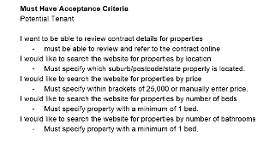

# Artefact 3 (Test data)

Nat and I created a few test cases consisting of combinations of username and good and bad passwords for existing/non existing customers. Below is one instance of the Test data:

“Assumption of requirements

- Valid login and password combination

- Login is case sensitive

Test Data:

2 user accounts were created to be used in testing:

- User1 Attempt1!

- User2 Attempt1234!

Test Cases

- Valid login/valid password User1/Attempt1! Logged in

- Invalid login/Valid password User22/Attempt1234!

- Valid login/ Valid password User2/Attempt1234!”

# Artefact 4 (Sketches)

As part of my contribution it was my job along with fellow group member (Nat Alkass) to sketch the website designs. This includes everything from the log-in page, homepage, user profile to the music and video players. This was all to provide our Computer science team members with paper designs to base our website off when coding. I developed 8 in-depth sketches including the following:

1. Log-in screen

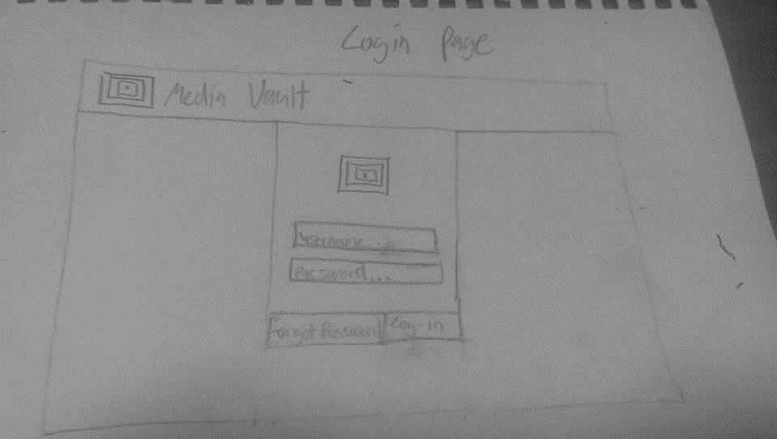

1. Sign-up screen

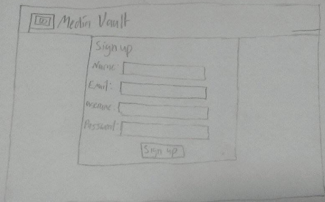

1. Search bar by itself

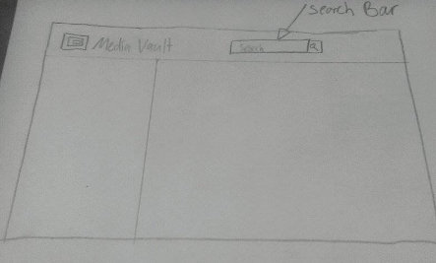

1. (drop down menu from user icon)

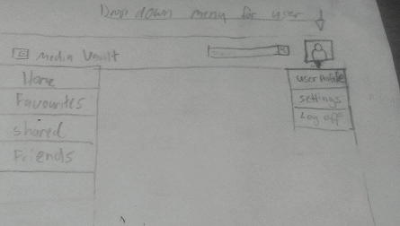

1. User Profile

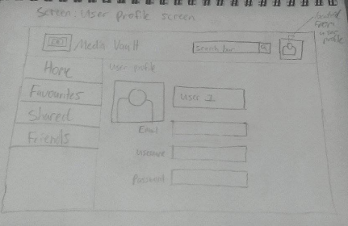

1. Video Player

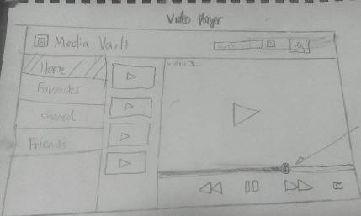

1. All contacts

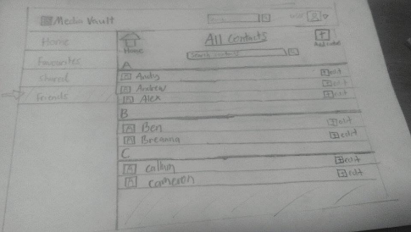

1. Add a contact

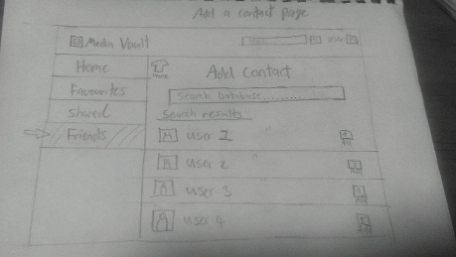

# Artefact 5 (sketches after client feedback)

When showing the client team the initial designs which can be seen above the clients had other suggestions for improvement. They stated that the tabs which are located on the right hand side would look better on the top. They also gave suggestions for colour which they chose dark blue for the “Media Vault” title banner and a light blue when a button is pressed. They however liked the other designs such as the video, image and how the contacts page was laid out. Below is the UI designs after consulting with the clients:

* 1. sign in screen

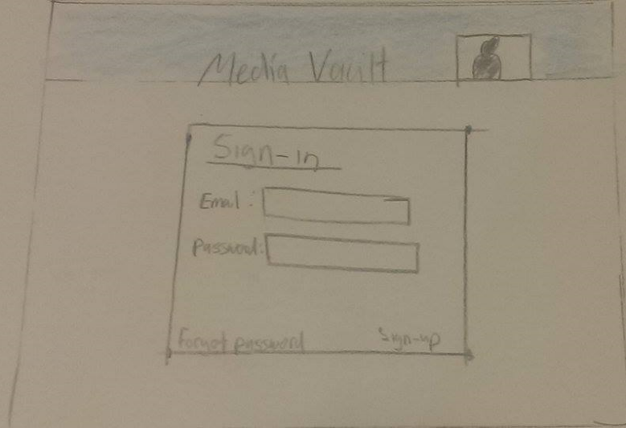

* 1. Sign-up screen

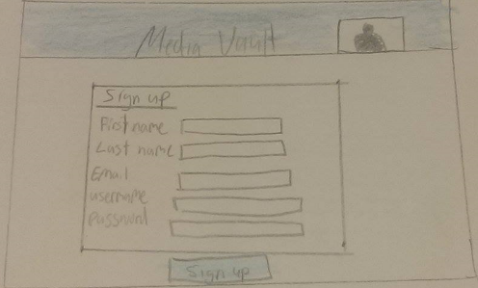

* 1. Search bar design screen

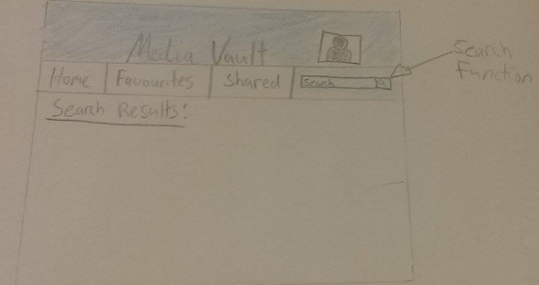

* 1. User profile screen

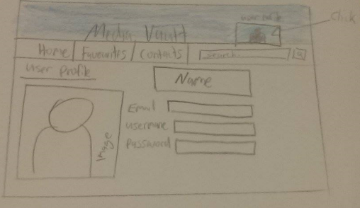

* 1. Image slideshow screen

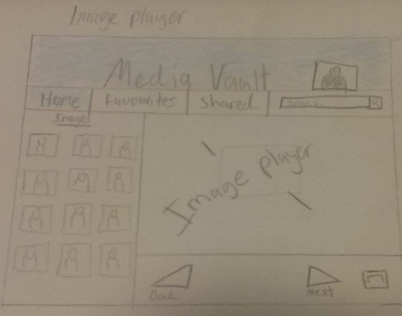

* 1. Video Player screen

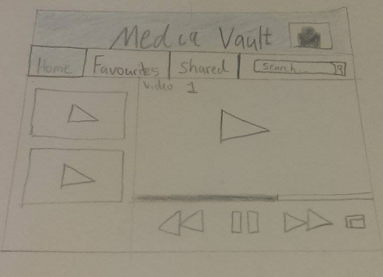

* 1. All contacts screen

